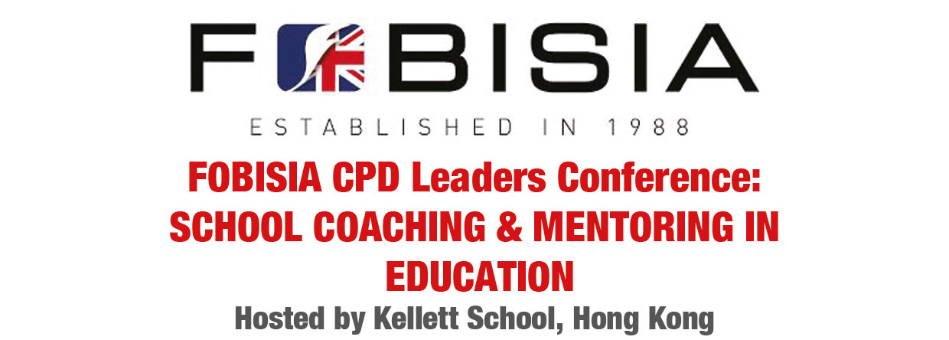
11th & 12th September 2015

Lynn Anderson |  | Gavin Lazaro
Andrew Atkinson |  | David Lousley
Louise Bateman |  | Mary McAloon
Simon Clarke |  | Kevin McGee
Mick Farley |  | Jo Osman
Diane Field |  | Brad Owen
David Foster |  | Cathy Poole
Anna Goodwin |  | Steve Priest
Pauline Gradden |  | Mahua Raychaudhuri
Rebecca Graves |  | Benyna Richards
Simon Graves |  | Matthew Savage
Deirdre Grimshaw |  | Simi Shah
Mel Hall |  | Nicholas Sheehan
Christine Haslett |  | Jenny Shek
Jane Hendley |  | Ivan Sturgess
Jackie Houghton |  | Neil Tamlyn
Mark Howe |  | Andrea Taylor
Barbara Justham |  | Cathy Taylor
Staci Kalmbacher |  | Jaime Thistleton
Emma Kato |  | Ailsa White
James Krishnan |  | Daphne Wong
Jo Laufer |  | Irene Yu

Learning intentions
- To provide an introduction to the core skills of coaching.
- To understand the theory and practice of coaching and where it could impact individual and school development.
- To consider how a coaching approach can be introduced and a coaching culture embedded in order to enhance
the life of your school.
Thursday 10th September 2015
Time | Description | Led by | Location
19:00 | Optional evening entertainment:  Dinner and drinks at the Globe  Additional Costs: $200 – 300 HKD for dinner | Jenny Shek | Meet in hotel lobby
Friday 11th September 2015
8:00 | Bus leaves L’hotel Causeway Bay | Cathy Poole/Jenny Shek | Meet in hotel lobby
8:30 | Arrival, registration and refreshments |  | Kellett School  Kowloon Bay Campus
8:45 | Welcome by Principal, Kellett School  Logistics | Ann McDonald  Jenny Shek | KLB Prep Hall
9:00 | Welcome by Chair of FOBISIA CPD | Jackie Houghton | KLB Prep Hall
9:45 | An introduction to coaching - the theory | Dr Neil Suggett, CBE | KLB Prep Hall
11:00 | Break
11:15 | The GROW model - coaching practice | Dr Neil Suggett, CBE | KLB Prep Hall
12:30 | Tour of the school | Kellett Sixth Form students
1:15 | Lunch
1:45 | Listening for understanding | Dr Neil Suggett, CBE | KLB Prep Hall
3:00 | Break
3:15 | Questioning for depth | Dr Neil Suggett, CBE | KLB Prep Hall
4:15 | Coaching Triads | Dr Neil Suggett, CBE | KLB Prep Hall
5:00 | Buses depart for L’hotel Causeway Bay |  | Front entrance of Kellett School
19:00 | Optional evening entertainment:  Buffet dinner and drinks at Bombay Dreams, SOHO  Additional Costs: $330 for food only | Jenny Shek | Meet in hotel lobby

Saturday 12th September
8:00 | Bus leaves L’hotel Causeway Bay | Jenny Shek | Meet in hotel lobby
8:45 | Review of the learning from day one | Dr Neil Suggett, CBE | KLB Prep Hall
9:00 | Building a coaching culture in your school | Dr Neil Suggett, CBE | KLB Prep Hall
10:30 | Break
10:45 | Improving performance through coaching | Dr Neil Suggett, CBE | KLB Prep Hall
12:15 | 'Go for it' - making it happen | Dr Neil Suggett, CBE | KLB Prep Hall
12:45 | JAWs Information  Changes, updates, CPD Leader responsibility and JAW calendar | Jackie Houghton | KLB Prep Hall
1:15 | Lunch
2:00 | A school action plan for coaching | Dr Neil Suggett, CBE | KLB Prep Hall
2:45 | Review and Next steps | Dr Neil Suggett, CBE | KLB Prep Hall
3:15 | Regional meetings |  | Prep Classrooms
4:45 | Goodbye and thank you
5:00 | Bus departs Kellett School to hotel |  | Front entrance of Kellett School
Sunday 13th September
Executive Committee Meeting (9am – 12pm) |  |  | L’hotel Causeway Bay

Kellett School Association Limited
Tel: (852) 3120 0700
Pok Fu Lam Campus 2 Wah Lok Path, Wah Fu, Pok Fu Lam, Hong Kong Fax: (852) 2875 0262
Kowloon Bay Campus 7 Lam Hing Street, Kowloon Bay, Hong Kong Fax: (852) 2305 2292
www.kellettschool.com

